Exercise Solutions for Chapter 6: Nonlinear Control
1. Perhaps the most popular nonlinear chemical engineering system is the nonisothermal CSTR in which the single, irreversible reaction 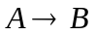is taking place. The model is given as:
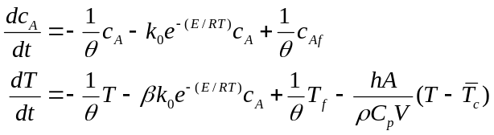
where: 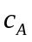is the concentration of reactant A in the reactor while T is reactor temperature, =V/F is the mean residence time in the reactor, k=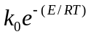 is the reaction rate constant, 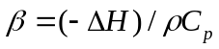 is a heat of reaction parameter, h as the coil heat transfer coefficient, A the total coil heat transfer area, and 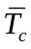 is the average temperature along the length of the coil. Linearize this set of equations around the steady states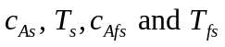.

Answer:
For the model:
define
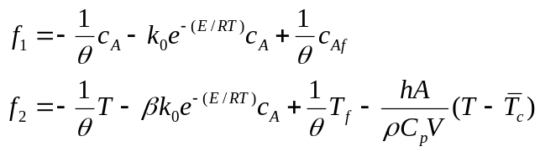
and
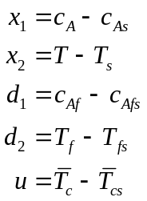
The required linearization may be achieved by obtaining a complete linear approximation in terms deviation variables, which takes the form
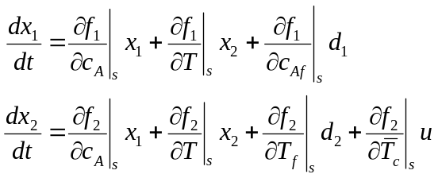
we obtain
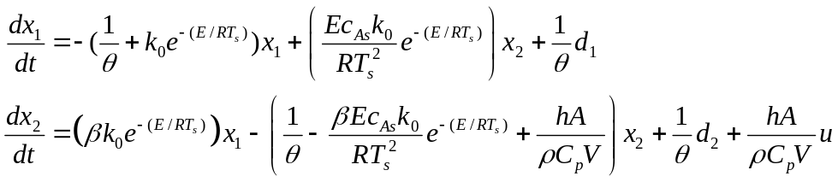
Alternatively, the taylor series approximation:
could be simply be introduced for the nonlinear 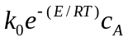term in the original equation. This will result the same set of equations upon simplification.

2. A reactor used for the free-radical polymerization of methylmethacrylate (MMA) using azo-bis-isobutyronitrile (AIBN) as initiator, and toluene as solvent, is modeled by the following set of equations:
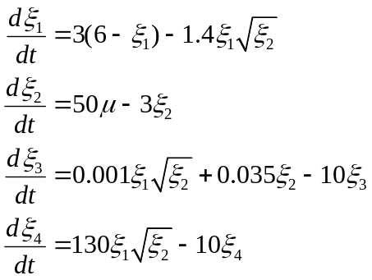
along with 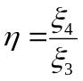. Here, 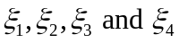 respectively represent the dimensionless monomer concentration, initiator concentration, bulk zeroth moment, and bulk first moment; is the number average molecular weight; and , is the volumetric flowrate of the initiator.
(a) Given an operating steady-state value, 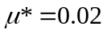 , obtain from the modeling equations the corresponding steady-state values for 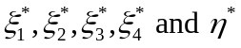. [Answer: ]
(b) Linearize the model equations around the steady-state values obtained in part (a), define the deviation variables 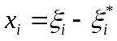 i = 1,2,3,4; 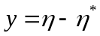; 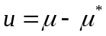; and obtain an approximate transfer function model relating y to u.

Answer:
(a) For the model
the steady state conditions can be solved by
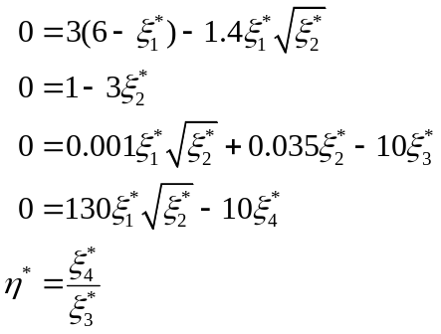
we obtain
- Using the fact that given
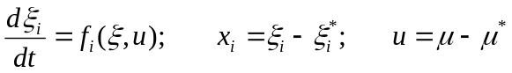
upon linearization, yield
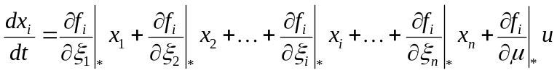
to obtain the following linearization of the polymer reactor model
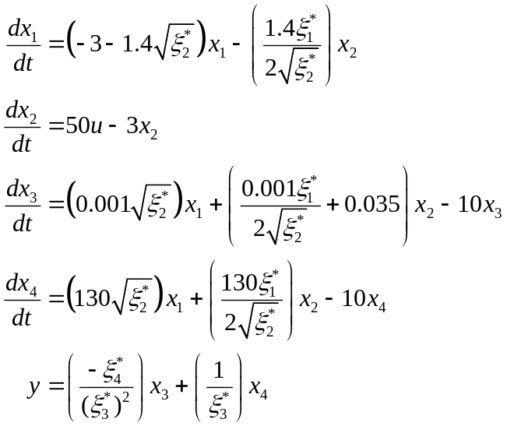
and upon introducing numerical values
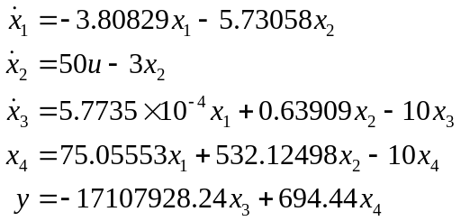
taking Laplace transform and rearranging, obtain
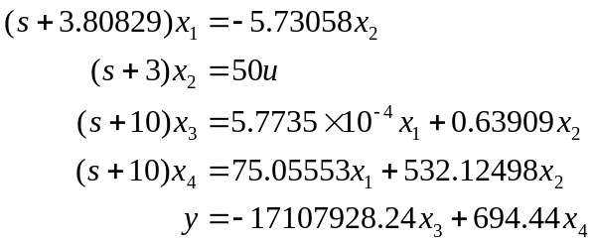
upon manipulation
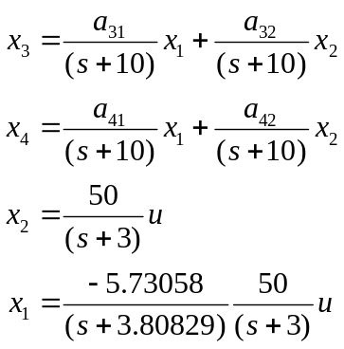
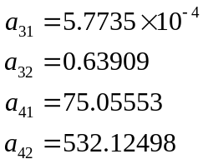
eliminate x₁ and x₂, in terms of input and output, we obtain
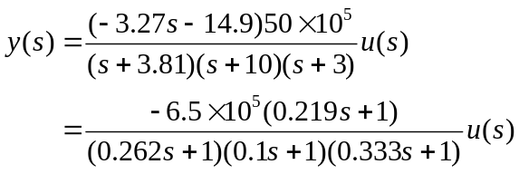
as the approximate transfer function model.
Owning to the presence of the zero, the phase angle for this transfer function never cross over -180⁰. Thus, the Bode stability criterion can not in principle be applied fro this transfer function, there is no finite k_{u}. The controller may be designed by any suitable method.
In practice, if a process model is unavailable, the procedure illustrated in (b) will be preferable provided process operations permit step tests. If process upsets are unacceptable, then a process model must be developed and then linearization approach may be used.
3. A mathematical model for the level of gasoline in a hemispherical storage tank is given as:
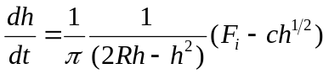
where R is the radius of hemispherical tank, F_{i} is the flowrate of gasoline into the storage tank.
(a) Linearize the original mathematical model, using a first-order Taylor series expansion; obtain an approximate transfer function model. Given a specific tank with parameters R = 2m, and c = 1.5m^{5/2}/min.), operating at initial steady-state conditions: F_{is} = 1.35 m³/min, h_{s}= 0.81m; [Answer: 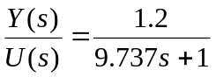]
(b) Convert the original nonlinear model equation to the first-order linear differential equation:
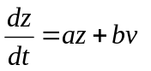
show explicitly what the variable z, v, and constants a and b are. [Answer: 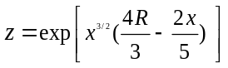; 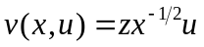]
(c) If instead it is desired to convert the model to the form
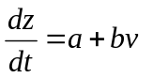
what nonlinear transformation will be required? [Answer: 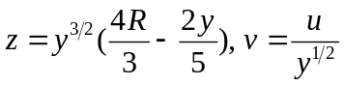]
Answer:
(a) The original process model
when linearized around 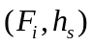 becomes
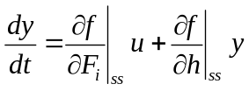
where
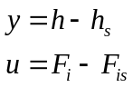
and
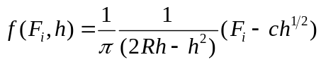
For R = 2m, and c = 1.5m^{5/2}/min., operating at initial steady-state conditions: F_{is} = 1.35 m³/min, h_{s}= 0.81m; it becomes
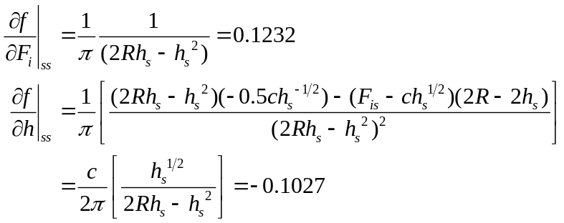
The linear equation is obtained as
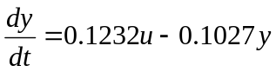
or

- For the model
write
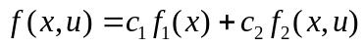
where
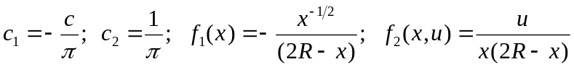
Consider a new variable z(x).
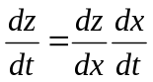
Then
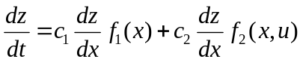
If z(x) is chosen such that
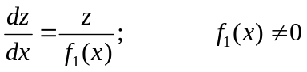
the solution is
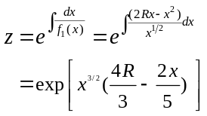
it becomes,
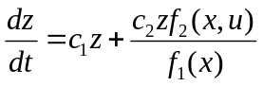
That is,
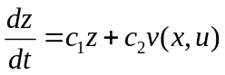
where
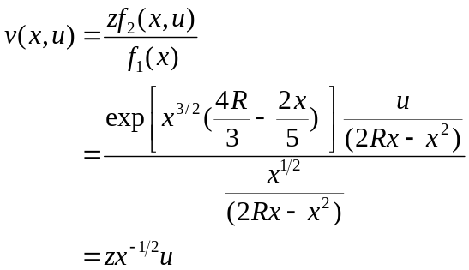
let 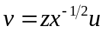, we finally obtain
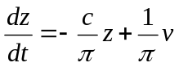
with
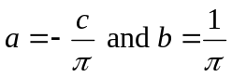

(c) Rearrange the model as
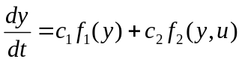
where
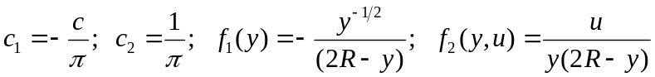
consider a transformation 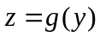and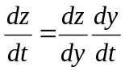
we obtain
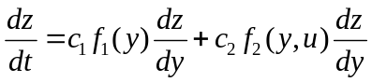
For the transformed model to have the form
it is required that
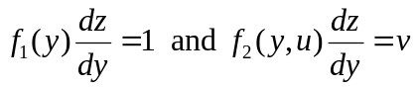
which results
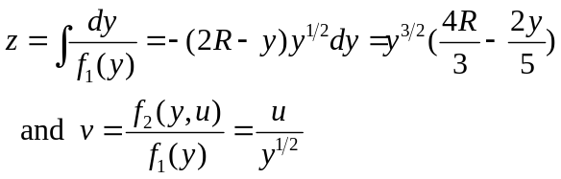

4. A mathematical model for the isolated population dynamics of a typical generative biological system is given by:
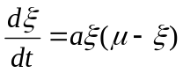
where
is the instantaneous population variable
a is a characteristic constant of the biological system
is the independent "source" term
a). For any given constant value 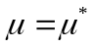, solve the model explicitly, given the initial population 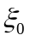at  and show the time behavior of is given by
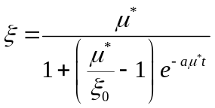
and hence establish that at steady state, as 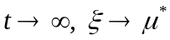. Also establish from the nonlinear model the steady-state relationship between the nontrivial equilibrium points 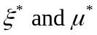. What does this indicate about the process steady-state gain?
(b) Linearize this model around an arbitrarily specified equilibrium point indicated by , define the deviation variables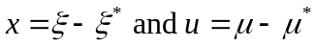, obtain an approximate transfer function relating x to u, and show that the steady-state gain indicated by this approximate transfer function is in fact entirely independent of the actual equilibrium point around which the model was linearized. What is the indicated apparent time constant? [Answer: 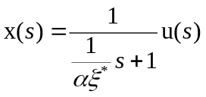]
Answer:
a) The biological system given by:
is solved at:
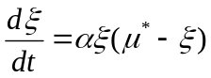
Separating the variables and partial fraction expansion gives
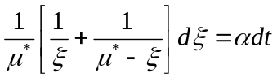
Integrating both sides, yield
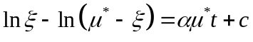
or
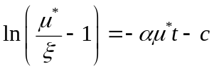
The arbitrary integration constant c, is obtained from the given initial conditions, 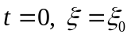 so that
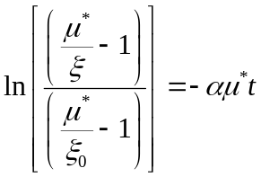
Rearrange to give
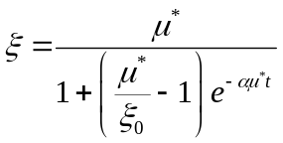
as required.
- As 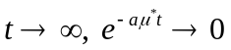, and 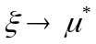.
- For the original differential equation, at steady state
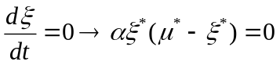
the only non trivial solution is 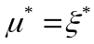, indicating process gain is 1.

b) The linearized model is obtained as follows:
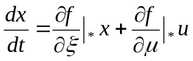
with 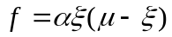, i.e.
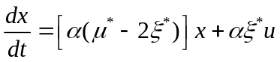
Laplace transformation and simple algebraic manipulation give
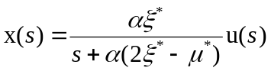
or , since , gives
and show that the steady-state gain is always equal to 1 regardless 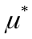 and 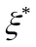, the apparent time constant is 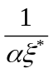.

c) For a particular system with characteristic constant 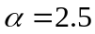, and an initial population variable 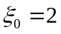, and 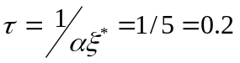.
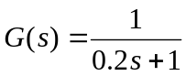
and compare with the nonlinear model using simulation
5. For many chemical and biological processes, the steady-state gain changes when a process operating condition such as throughput changes. Consider a biomedical application where a drug flow rate is used to control blood pressure. The steady-state gain K_{p} varies with the manipulated variable u according to the relation,
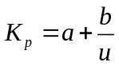
where u > 0 and a and b are constants that have been determined by fitting steady-state data. Suggest a modification for the standard PID controller to account for this variation in the process gain. Justify your answer. (In the above equation, u is not a deviation variable).

Answer:
Supposing a first-order plus dead time process, the closed-loop transfer function is
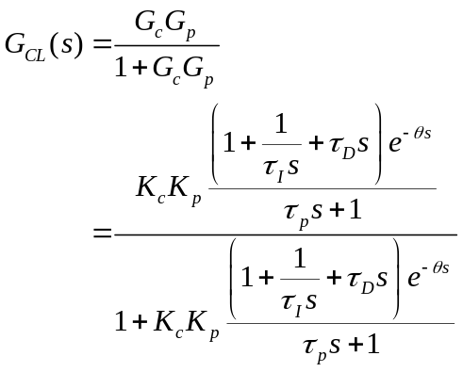
Notice that Kc and Kp always appear together as a product. Hence, if we want the process to maintain a specified performance (stability, decay ratio specification, etc.), we should adjust Kc such that it changes inversely with Kp; as a result, the product KcKp is kept constant. Also note, that since there is a time delay, we should adjust Kc based upon the future estimate of Kp:
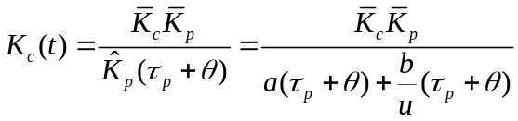
where 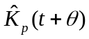is an estimate of Kp time units into the future.
6. The product quality from a catalytic tubular reactor is controlled by the flow rate of the entering stream, utilizing composition measurements from a process gas chromatograph. The catalyst decays over time and once its overall activity drops below 50%, it must be recharged. Deactivation usually takes two to three months to occur. One measure of catalyst activity is the average of three temperature measurements that are used to estimate the peak temperature. Discuss how you would employ an adaptive control scheme to maintain product quality at acceptable levels. What transfer functions would need to be determined and why?

Answer:
This is an application where self-tuning control would be beneficial. In order to regulate the exit composition, the manipulated variable (flowrate) must be adjusted. Therefore, a transfer function model relating flowrate to exit composition is needed. The model parameters will change as the catalyst deactivates, so some method of updating the model (e.g., periodic step tests) will have to be derived. The average temperature can be monitored to determine a significant change in activation has occurred, thus indicating the need to update the model.
7. A second-order process is controlled by a PID controller. The desired closed-loop servo transfer function is
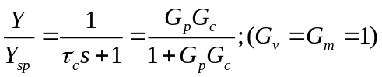
and the process model is
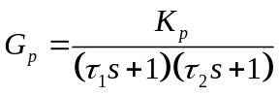
- Derive a control law that shows how to adjust K_{c}, 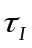, and 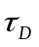 based on variations in K_{p}, , and 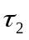 and the desired closed-loop time constant 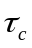.
- Suppose = 3, = 5, and K_{p} =1. Calculate values of K_{c}, and to achieve =1.5. Show how the response deteriorates for changes in the following model parameters when the controller remains unchanged:
- K_{p} = 2
- K_{p} = 0.5
- = 10
- = 1

Answer:
a)
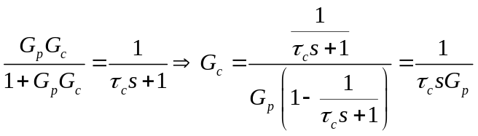
Substituting for Gp

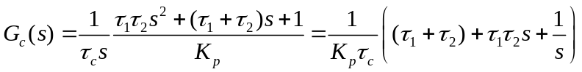
Thus, the PID controller tuning constants are
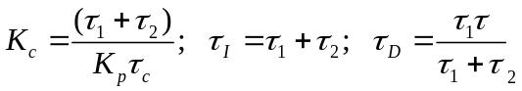
b) For 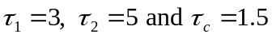, we have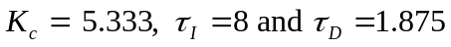. Using this PID controller, the closed-loop response will be first order when the process model is known accurately. The closed-loop response to a unit step-change in the set-point when the model is known exactly is shown in b). It is assumed that was chosen such that the closed loop response is reasonable, and the manipulated variable does not violate any bounds that are imposed. An approximate derivative action is used by Simulink-MATLAB, namely 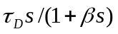when β=0.01
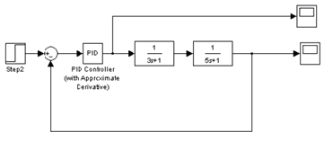
Figure 19a. Simulink block diagram for perfect model.
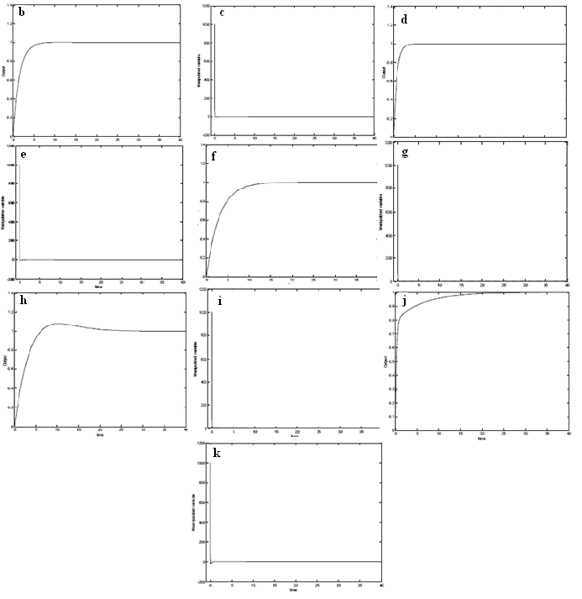
Figure S8. b) Output (no model error), c) Manipulated variable (no model error), d) Output (Kp = 2), e) Manipulated variable (Kp = 2), f) Output (Kp = 0.5), g) Manipulated variable (Kp =0.5), h) Output (τ2 = 10), i) Manipulated variable (τ 2 = 10), j) Output (τ 2 = 1), k) Manipulated variable (τ 2 = 1)
  - The closed-loop response when the actual Kp is 2.0 is shown above. The controlled variable reaches its set-point much faster than for the base case (exact model), but the manipulated variable assumes values that are more negative (for some period of time) than the base case. This may violate some bounds.
  - When Kp = 0.5, the response is much slower. In fact, the closed-loop time constant seems to be about 3.0 instead of 1.5. There do not seem to be any problems with the manipulated variable.
  - If (= 10), the closed-loop response is no longer first-order. The settling time is much longer than for the base case. The manipulated variable does not seem to violate any bounds.
  - Both the drawbacks seen above are observed when= 1. The settling time is much longer than for the base case. Also the rapid initial increase in the controlled variable means that the manipulated variable drops off sharply, and is in danger of violating a lower bound.

8. The Ideal Gas Company has a process that requires an adaptive PI controller, but the company capital budget has been frozen. Mr. A has been given the job to develop a homegrown, cheap adaptive controller. It has been suggested that the closed-loop response after a disturbance can be studied to determine how to adjust K_{c} and incrementally up or down, using measures such as settling time, peak error, and decay ratio. Mr. A has proposed the following algorithm: If decay ratio > 0.25, reduce K_{c}. If decay ratio < 0.25, increase K_{c}. He is not sure how to adjust . Critique his rule for K_{c} and propose a rule for changing .

Answer:
Based on PID principles, increasing the gain of a controller makes it more oscillatory, increasing the overshoot (peak error) as well as the decay ratio.
Therefore, if the quarter-decay ratio is a goal for the closed-loop response (e.g., Ziegler-Nichols tuning), then the rule proposed by Mr. A should be satisfactory from a qualitative point of view. However, if the controller gain is increased, the settling time is also decreased, as is the period of oscillation.
Integral action influences the response characteristics as well. In general, a decrease in gives comparable results to an increase in Kc. So, Kc can be used to influence the peak error or decay ratio, while can be used to speed up the settling time (a decrease in decreases the settling time).

